PROJECT—CYBER SECURITY INCIDENT TRACKER
BY —SHUBHAM SHARMA
R.NO-24BCY10391

- Get API
URL -http://localhost:3000/api/users
No json file
Response
[
{
"user_id": 1,
"name": "Shubham",
"email": "shubham@gmail.com",
"role": "Admin"
}
]
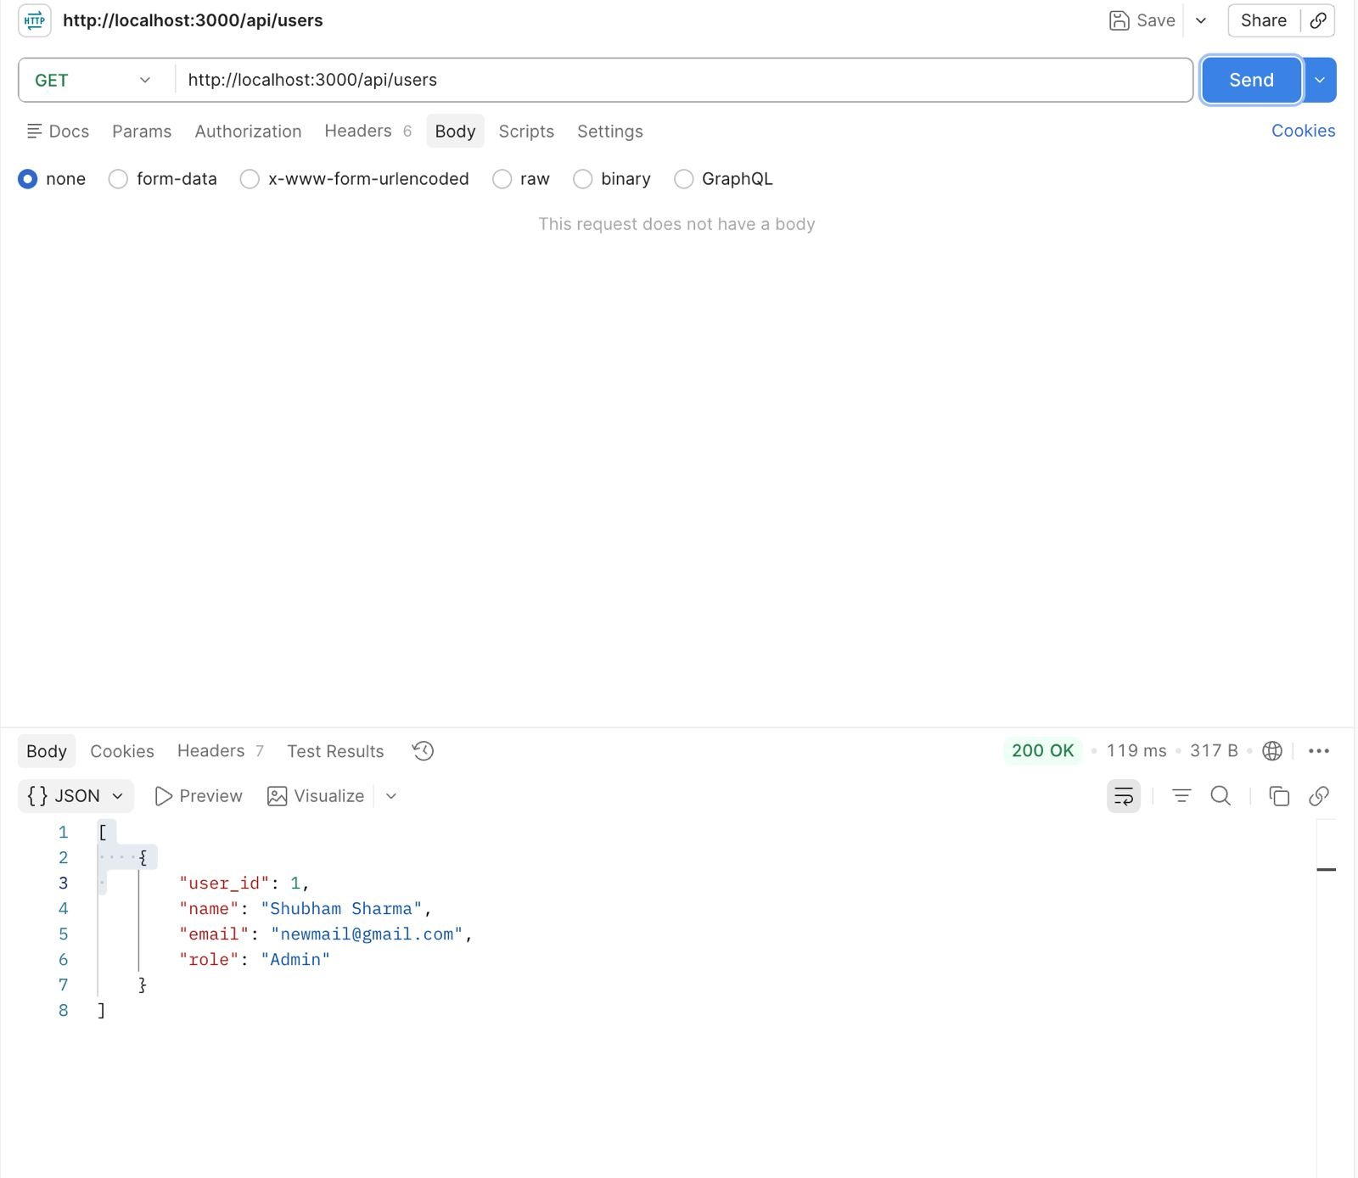
This is a GET request to fetch all registered users from the MySQL database. No request body is required. The server queries the users table using Sequelize and returns an array of user objects. The response shows user_id, name, email, and role fields. Status 200 OK confirms successful retrieval.

2.PUT api
URL—http://localhost:3000/api/users/1
JSON file—[
{
“user_id” :1,
“Name”:”shubham”,
“Email”:”shubham@gmail.com",
“Role”:”admin”
}
]

Response-{
“Message:”user updated”
}
This is a PUT request to update an existing user's data by their user_id (here, id = 1). The request body contains updated fields sent as raw JSON. The server finds the user in MySQL using Sequelize's update() method and modifies the record. The response { "message": "User Updated" } with status 200 OK confirms the update was successful.

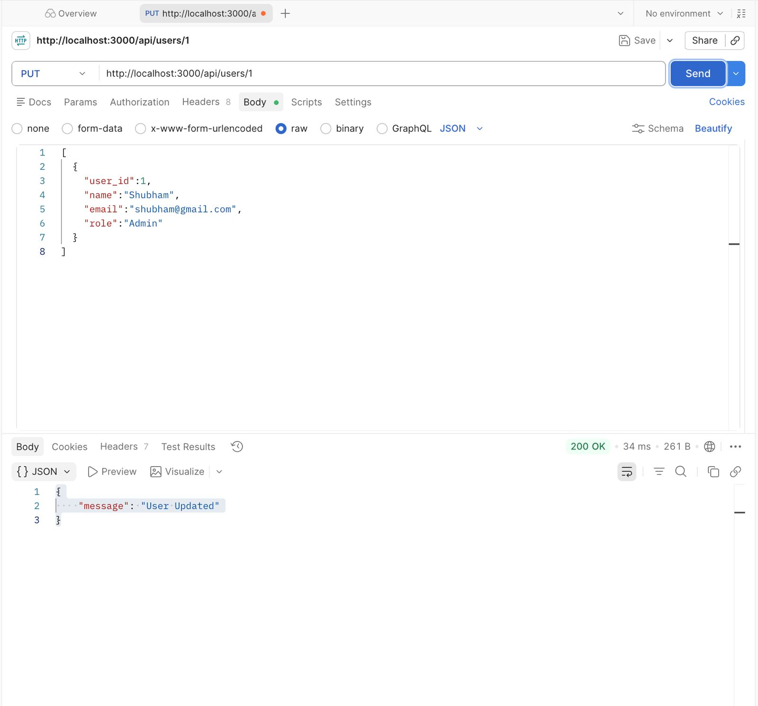

3.1.DELETE api
URL—http://localhost:3000/api/users/1
JSON file—{
“Name”: “test user”,
“Email”: “test@gmail.com",
“Role” : “employe”
}
Response—{
“Message” : “user deleted”
}
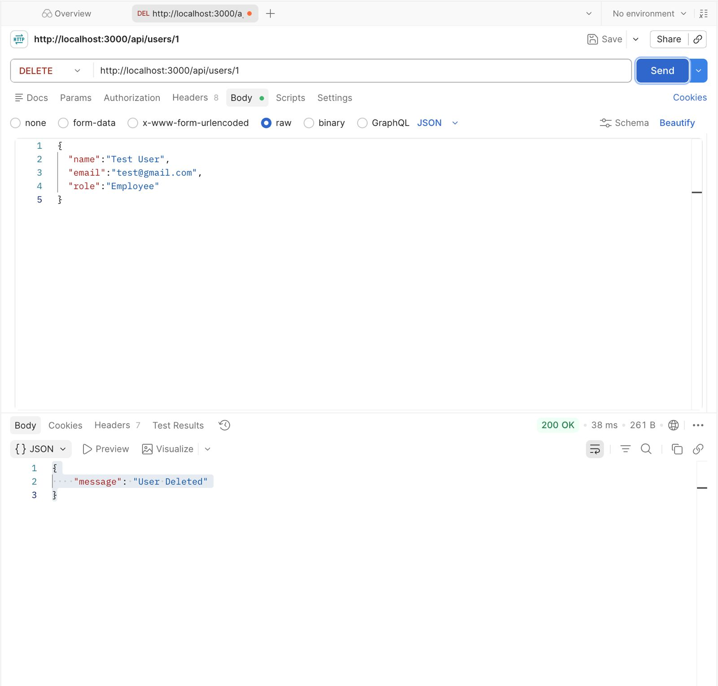
This is a DELETE request to remove a user record by user_id. The server locates the user in the MySQL users table and deletes the entry using Sequelize's destroy() method. The response { "message": "User Deleted" } with 200 OK confirms deletion. Note: DELETE requests typically don't require a request body — the body shown here was leftover from testing and is ignored by the server.

3.1.2DELETE api
URL—http://localhost:3000/api/users/2

JSON file—{
“Message” : “user deleted”
}
response—{
“Message” : “user deleted”
}
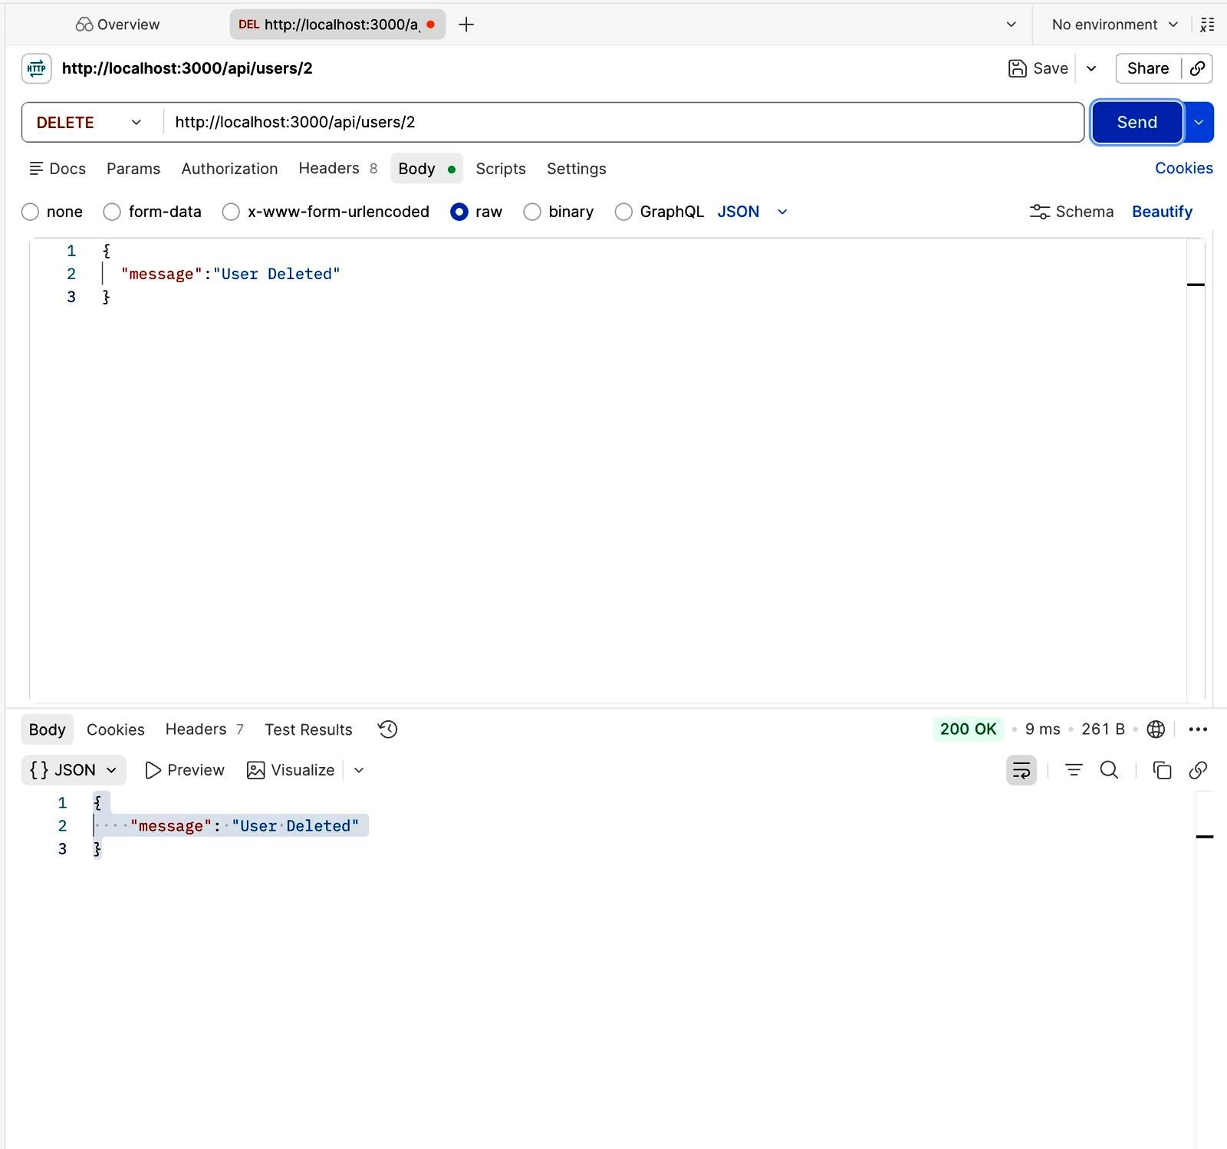
This is a second DELETE test, removing user with user_id = 2. This demonstrates that the delete endpoint works consistently across multiple records. The 200 OK response with { "message": "User Deleted" } confirms the operation. Response time of 9ms shows efficient database query execution.
4.POST api
URL—http”//localhost:3000/api/incidents

JSON file—{
“incidentID” :1,
“Filename” : “phishing_email.png”,
“Description” : “screenshot of phishing email”,
“uploadedBY” : “shubham”
}
Response
{
"message": "incident Created",
"id": 2
}
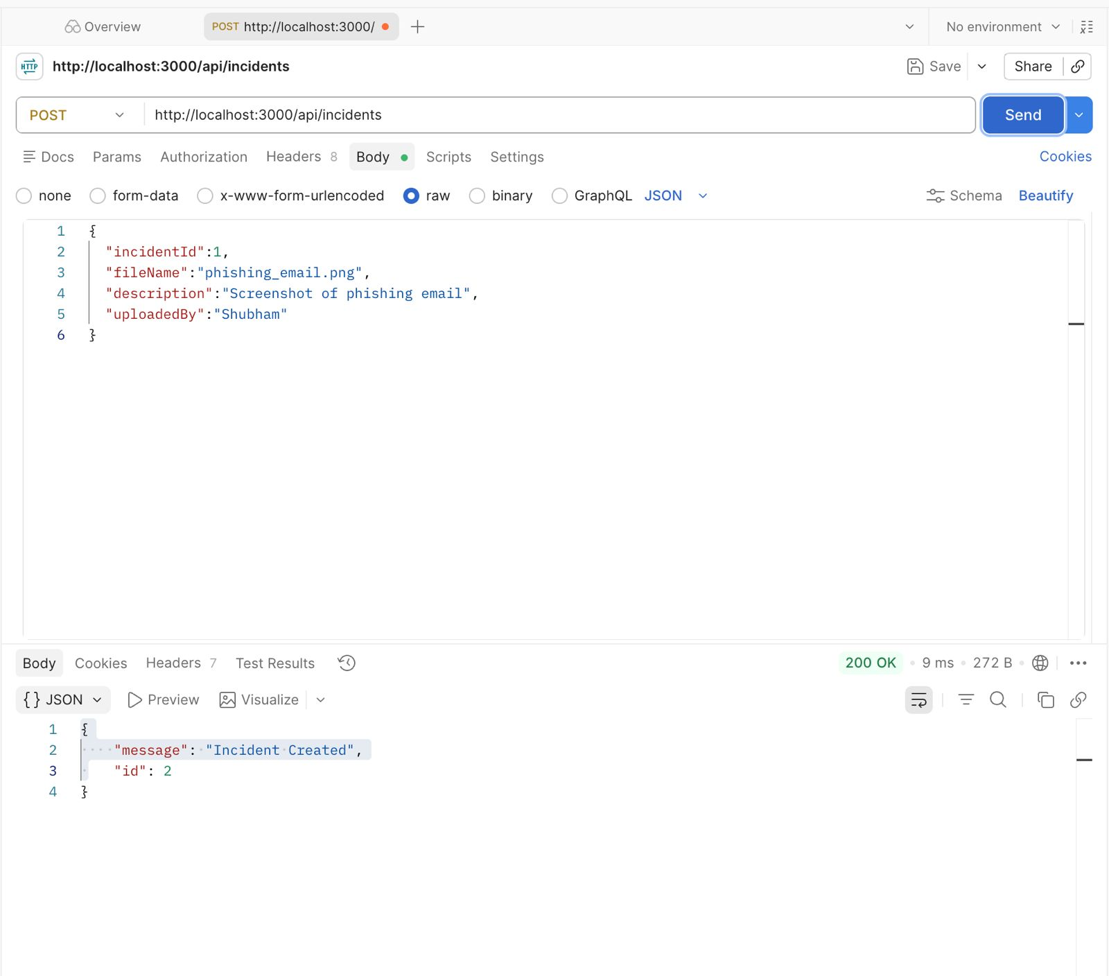
This is a POST request to create a new incident evidence record in MongoDB. The JSON body contains incidentId, fileName, description, and uploadedBy fields. The server uses Mongoose to save this document to the evidences collection in the cybertracker database. The response { "message": "Incident Created", "id": 2 } with 200 OK confirms successful insertion. This demonstrates the dual-database architecture — incidents metadata is stored in MySQL while file evidence is stored in MongoDB.

Terminal screenshot showing connections
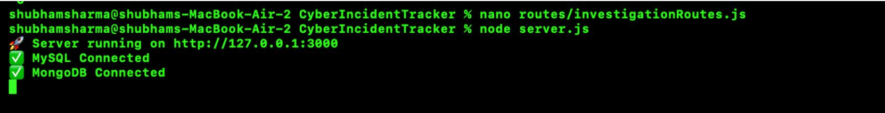
The terminal confirms that the Node.js/Express server started successfully on http://127.0.0.1:3000. Both database connections are active — MySQL Connected and MongoDB Connected — verifying that the dual-database setup is functioning correctly before API testing begins.

MongoDB compass screenshot
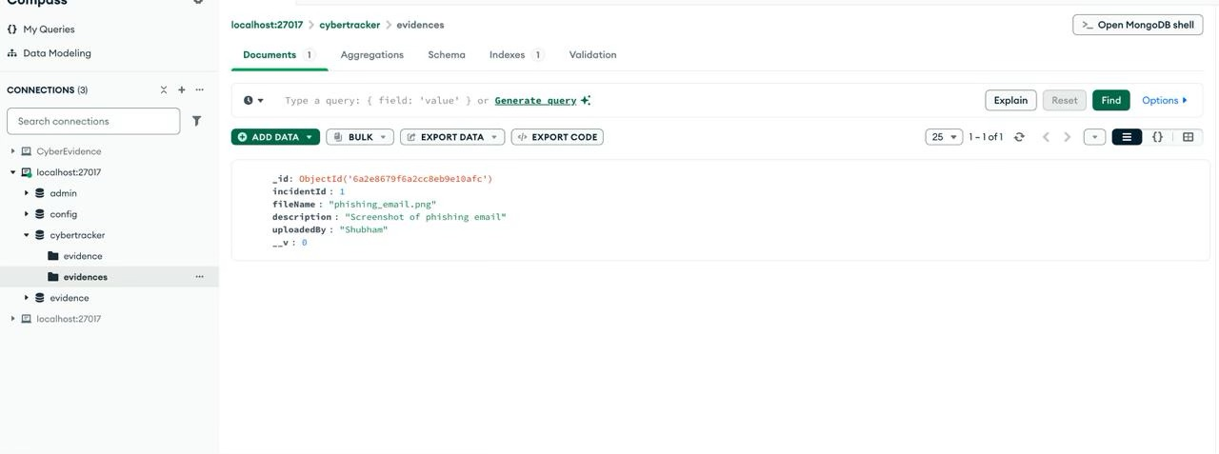
MongoDB Compass shows the cybertracker database with the evidences collection. The document stored after the POST request is visible, containing incidentId: 1, fileName: "phishing_email.png", description: "Screenshot of phishing email", and uploadedBy: "Shubham". This confirms that MongoDB is correctly storing unstructured evidence data as documents.
MySQL workbench screenshot
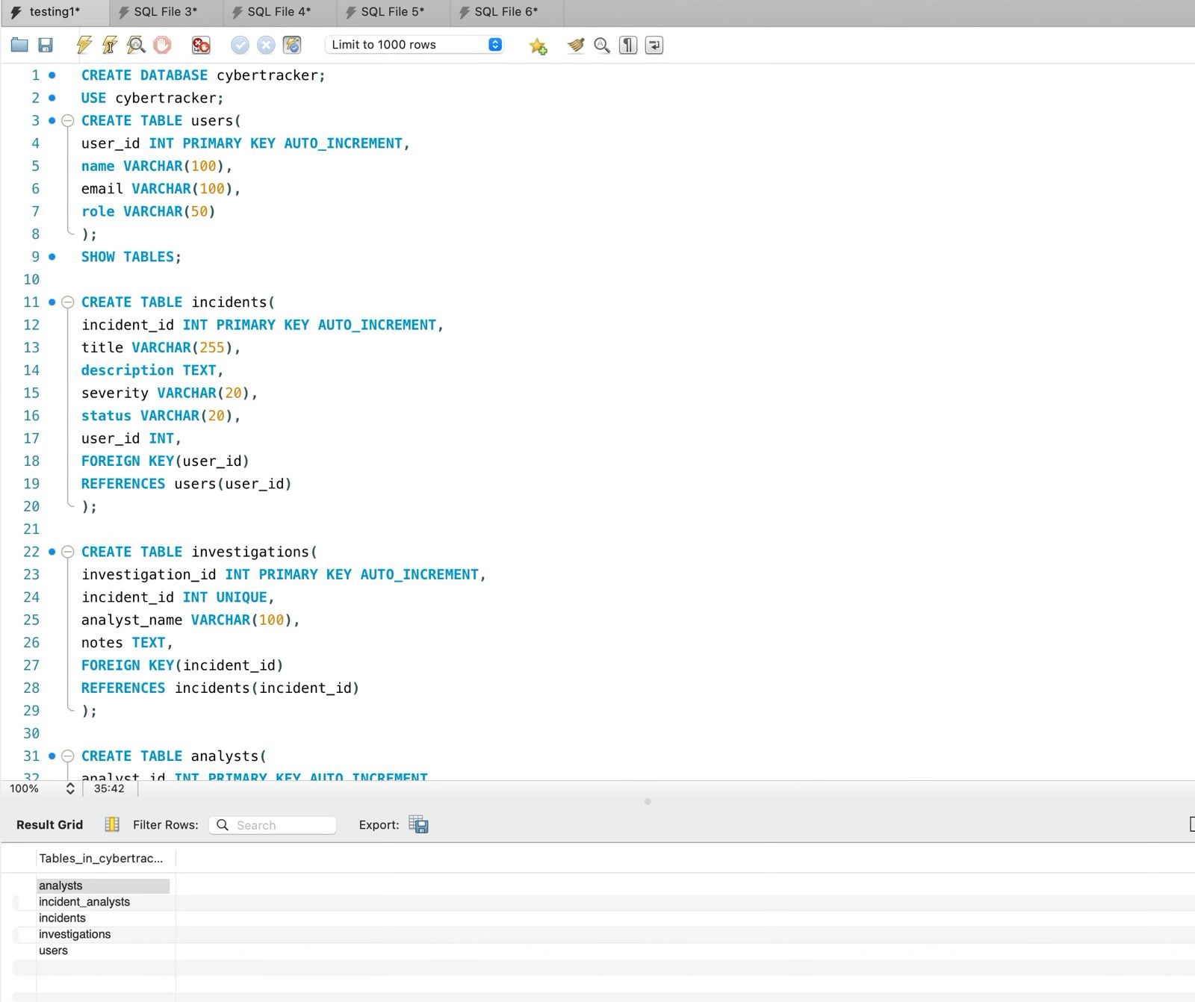
MySQL Workbench shows the schema of the cybertracker database. Tables created include users, incidents, investigations, analysts, and incident_analysts (junction table). The incidents table has a foreign key referencing users(user_id), demonstrating a Many-to-One (M:1) relationship. The investigations table references incidents(incident_id), showing a One-to-One (1:1) mapping. The incident_analysts junction table implements the Many-to-Many (M:M) relationship between incidents and analysts. The SELECT query result confirms data is persisted correctly in MySQL.

